Standards
Secure Sockets Layer (SSL)

SSL is the standard security technology for establishing an encrypted link between a web server and browser. This ensures that data passed between the browser and the web server stays private.
To create an SSL connection on a web server requires an SSL certificate.
The cloud provider’s computers then generate two cryptographic keys—a public key and a private key.

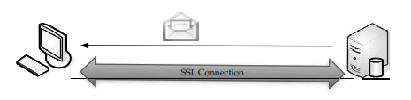
SSL Connection
1. The browser checks the web site’s certificate to ensure that the site you are connecting to is the real site and not someone else intercepting and spoofing the site.
2. The browser and web site decide on what type of encryption to use.
3. The browser and server send each other unique codes to use when encrypting information to be sent.
4. The browser and server use the encryption to start talking.
5. The browser shows the encrypting icon, and web pages are passed as secured.

Open ID:

OpenID is an open standard and decentralized authentication protocol

Users create accounts by selecting an OpenID identity provider and then use those accounts to sign onto any website that accepts OpenID authentication.

OpenID allows you to use an existing account to sign in to multiple websites, without needing to create new passwords.

It works on OAuth 2.0 protocol.
Please download below topics material from web: (10 features)
***************************************************
- HTML features
- CSS features
- DHTML features
- JAVA SCRIPT features
- XML features (imp)

Web services

Definition: A web service, as defined by the World Wide Web Consortium (W3C), “is a software system designed to support interoperable machine-to-machine interaction over a network” that may be accessed by other cloud computing components.

Web services components:

- REST
- SOAP
- JSON

JSON :
JSON: JavaScript Object Notation.
JSON is a syntax for storing and exchanging data.
JSON is text, written with JavaScript object notation.
JSON is a lightweight data-interchange format
JSON is "self-describing" and easy to understand
JSON is language independent

Exchanging Data
When exchanging data between a browser and a server, the data can only be text.

Sending Data
If you have data stored in a JavaScript object, you can convert the object into JSON, and send it to a server:

Example
var myObj = {name: "John", age: 31, city: "New York"};
var myJSON = JSON.stringify(myObj);
window.location = "demo_json.php?x=" + myJSON;

Receiving Data
If you receive data in JSON format, you can convert it into a JavaScript object:

Example
var myJSON = '{"name":"John", "age":31, "city":"New York"}';
var myObj = JSON.parse(myJSON);
document.getElementById("demo").innerHTML = myObj.name;

Storing & Retrieving Data
When storing data, the data has to be a certain format, and regardless of where you choose to store it, text is always one of the legal formats.
JSON makes it possible to store JavaScript objects as text.

Example
Storing data in local storage
// Storing data:
myObj = {name: "John", age: 31, city: "New York"};
myJSON = JSON.stringify(myObj);
localStorage.setItem("testJSON", myJSON);
// Retrieving data:
text = localStorage.getItem("testJSON");
obj = JSON.parse(text);
document.getElementById("demo").innerHTML = obj.name;

SOAP
- SOAP stands for Simple Object Access Protocol
- SOAP is an XML based protocol for accessing Web Services.
- SOAP is based on XML
- SOAP is a W3C recommendation

REST
- REST stands for Representational State Transfer.
- REST is an architectural style.
- REST is based on XML
- REST is a W3C recommendation
- REST uses all HTTP Request types (GET, POST etc ...)
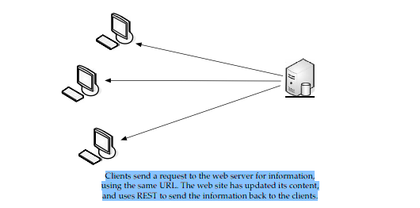

No. | SOAP | REST
1) | SOAP is a protocol. | REST is an architectural style.
2) | SOAP stands for Simple Object Access Protocol. | REST stands for REpresentational State Transfer.
3) | SOAP can't use REST because it is a protocol. | REST can use SOAP web services because it is a concept and can use any protocol like HTTP, SOAP.
4) | SOAP uses services interfaces to expose the business logic. | REST uses URI to expose business logic.
5) | JAX-WS is the java API for SOAP web services. | JAX-RS is the java API for RESTful web services.
6) | SOAP defines standards to be strictly followed. | REST does not define too much standards like SOAP.
7) | SOAP requires more bandwidth and resource than REST. | REST requires less bandwidth and resource than SOAP.
8) | SOAP defines its own security. | RESTful web services inherits security measures from the underlying transport.
9) | SOAP permits XML data format only. | REST permits different data format such as Plain text, HTML, XML, JSON etc.
10) | SOAP is less preferred than REST. | REST more preferred than SOAP.

